Háskólinn í reykjavík
CNC Foam cutter
A transition report
Fannar Andrason, Kristján Orri Magnússon, Sveinn Haukur Albertsson
April 1. 2011

The CNC foam cutter project started when it was requested by the head of the UAV lab at RU. The purpose of the machine is to cut out wing profiles for small ornithopter wing design research. This project was undertaken by students of the class Hönnun 1013 under the provision of Dr. Joseph Timothy Foley.

Contents

1. Introduction 3
2. Design review 4
3. Preliminary tests 6
4. Bill of materials 8
5. Decomposition and task list 9
6. Useage description 11
7. Shipping instructions 12
8. Maintenance and safety issues 13
9. Current status of project 13
10. Summary 13
11.Appendix 1 - Workplans 14

1. Introduction
The CNC foam cutter project was requested by Leifur Þór Leifsson, head of UAV lab at Reykjavik University. He wanted to be able to cut out predetermined wing profiles for reasearch and testing of small ornithopter wing design, for the allowable budget of 200.000 ISK. For comparison a similar(yet not fully comparable) device can be bought from the company Foamlinks starting at 4.000 USD, which is about 460.000 ISK (current rate). After a short briefing of the nature of his problem we were able to break down a list of functional requirements, using axiomatic design methology:
- Cut airfoils out of foam for ornithopter design research.
- Wing profile must be able to vary with span.
  - Twist, variable camber, sweep etc.
  - Specified tolerances +/- 0,5 mm.
- The requested dimensions are 50 cm wide, 25 cm high and 1 m long.
- Objective:
  - Make the machine cheaper than if imported.
  - Tailormake to the costumers needs.
To be able to satisfy all the requirements, we made a list of design parameters that should be kept in mind in solving the problem:
- Use a pretensioned hot electric resistance wire (i.e. Ni-Chr) to cut through foam pieces
    - Each end of wire fixed to a slider that can move in the plane perpendicular to the direction of wire (hereafter called X-Y plane).
    - 2 x 2 stepper motors drive lead screws to change position of wire fix point in X-Y plane.
- Wire fix point on each end must be able to move independently of each other
  - Wire must be able to elongate/shorten without loosing too much tension
    - Spring mechanism
  - Pretension must be about 150N to prevent inconsistent kerf.
- Dimensioning of frame design to allow for specified values.
    - Box frame to minimize bending of X-Y planes

  - Use cheap, standard profiles for components/subassemblies. Use cheap stepper motors for efficient open-loop design. Cheapest available lead screw chosen to minimize cost, without sacrificing precision and durability(compared to threaded shaft).
  - Design from skratch, design methods from CNC mill were examined and adjusted to our design.

2. Design review
From the beginning of the project, we realized that prevention of bending and jamming was the key aspect for a good design. By placing center of action correctly and applying Saint Venants principle on bearings and slider surfaces most of these potential problems can be avoided. As a measure to meet tolerances specifications, the frame and components must be designed rigidly. In our effort to comply to that criteria we decided to make a box frame instead of two cantilevers, which would require much more material for the same stiffness as the box frame.
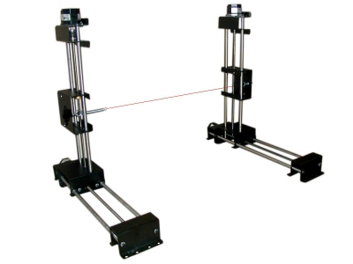
A Foamlinks hotwire cutter with cantilevers.
(Image from foamlinks.com)

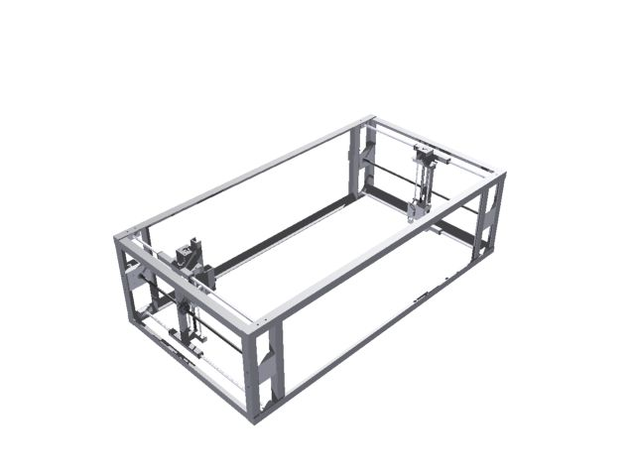
Our foamcutter design. The box frame should give more stiffness than the cantilever type.

Requirements for the slider assembly demand that they are fabricated precisely. To achieve the goal of jam and deflection prevention, a considerable effort was put in the design process. Also, from axiomatic point of view, the mechanism had to be broken down into parts that can be assembled and disassembled easily.
To achieve a smooth travel, the bearings for the X-direction slider are made of POM plastic and are a plug type for easy assemble. They are plugged in each of the profile end and have an inside diameter of 0.1 millimeter more than the leader rod diameter. Their length is kept at minimum to reduce friction. The center of action, i.e. the location of the lead nut, is located at the center of friction for the slider to achieve zero sum of moment loads.With respect to Saint Venants principle, that means that the characteristic ratio of 3-5 can be reduced, especially bearing in mind that other loads(from the wire) are insignificant. The same principles are applied to the Y-slider, but on a smaller scale, with the consequent design result that can be viewed below.
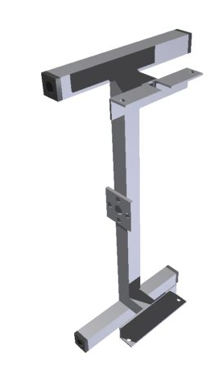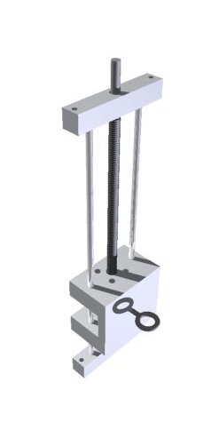
The Y-slider(right) slides into the L-profiles of the X-slider(left) and is bolted into place.The Y-slider is made from POM plastic for electrical insulation, good friction qualities and because press-fitting of leader rods are easy.
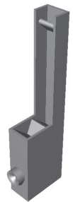
To ensure tension, while allowing the wire to elongate and shorten, a spring mechanism is mounted to one of the slide assemblies. The wire goes through a rounded leader, then on a grooved halfwheel with a diameter of 60 mm which changes the direction of the wire to point it upwards. There it connects to a spring which is constrained to a shaft that can be moved to adjust the pretension of the wire. The mechanism is pointed upward because other directions will limit the field of travel and to prevent it from sticking out of the side of the machine.

The spring mechanism(right).
The spring attaching shaft can be placed in multiple holes,
drilled in line down the profile (not shown on image).

As the motor mounts do not take any load other than torque from the motor it can be fabricated out of 1 mm thick sheet metal. That allows for small imperfections in fabrication and thus prevents high loads due to runout. The mount is although subject to testing and further developement if proven to deflect to that degree that it affects machine precision due to torque load.
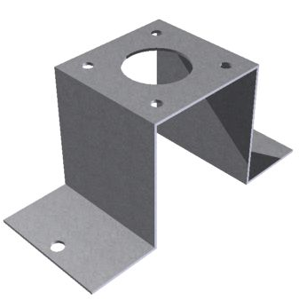
The motor mount for Y-slider.
When choosing mechanism to translate turning motion into linear motion, we used Ocham‘s razor to decide that the screw and nut method would be more suitable than belts or chains. We decided to rule out threaded shaft because it quickly wears out and is simply not ment for this application, even though it is commonly used for low-cost short lifetime applications . As a ball screw is very expensive we decided as a budget compromise to use leadscrew with a trapezodial thread which is way cheaper, yet satisfying our precisional requirements. The chosen leadscrew has a diameter of 10 mm and pitch of 2 mm. The cost of the screws and nuts is about 400 USD.

3. Preliminary tests
Preliminary test on hotwire indicated that a movement speed of 4 mm/s while applying 3A current to heat the wire would be ideal, i.e. the kerf will be consistent enough to meet the specified tolerances. A „feel“-test was performed on the stepper motor. It indicated that the step input has a range up to 700 Hz and with 24V as input voltage it gave sufficient amount of torque. The steppers have a precision of 1,8° per step which means that the distance traveled per step, d, is:
$$d=\frac{1,8}{360}∙2=0,01 [{mm}/{step}]$$
Also, as the upper limit of rotational speed are defined by the upper limit of step input frequency, the maximum speed of movement, v_{max} is:
$$v_{max}=\frac{700∙1,8}{360}∙2=7,0 [{mm}/s]$$
As the distance per step more than satisfies our specified tolerances and the maximum speed exceeds our ideal cutting speed of 4 mm/s, no gearing mechanism is neccesary. Therefore the motors can be directly coupled to the leadscrews.
Final design of the foam cutter.

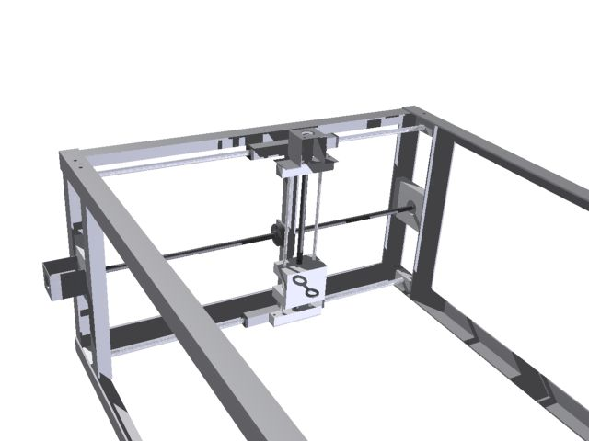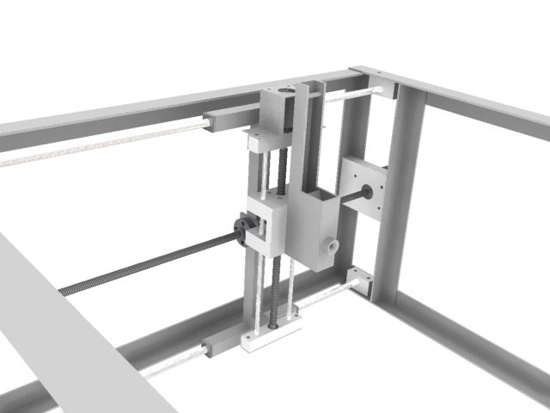
A close-up view of slider assemblies. Spring mechanism is attached on the image to the right.

4. Bill of materials

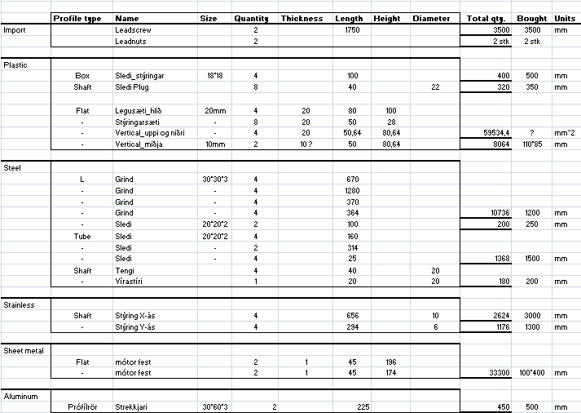

5. Decomposition and task list
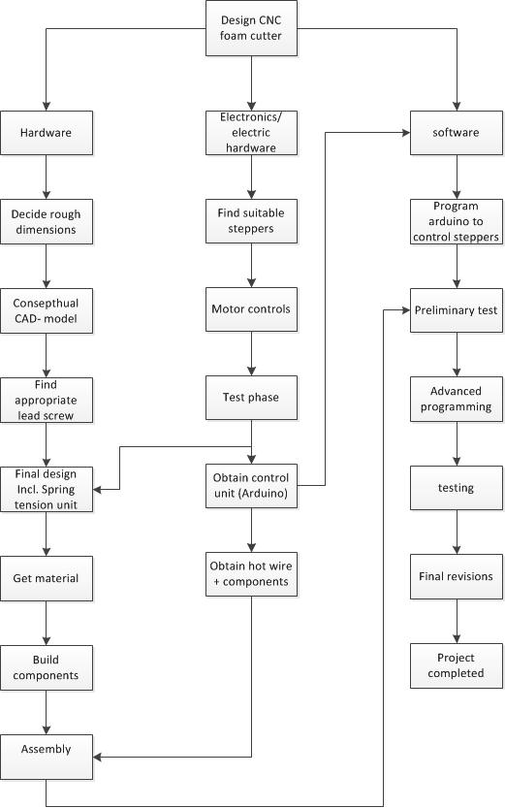
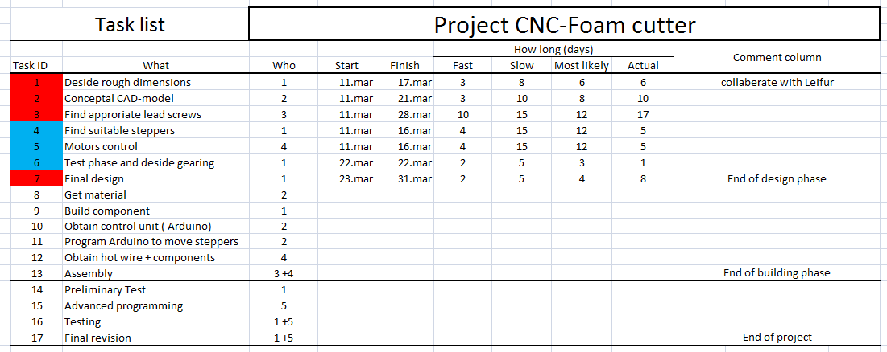

6. Useage description
A piece of foam is inserted from the top and fixed so one corner flushes with a fixed setsquare. The user then defines the two wing profiles that he wants to loft between. He also has to specify corresponding reference points for both profiles(e.g. location of max camber) which will be the starting point for the cutter. Finally, he specifies the length of the wing. The software then extrapolates on of the profiles to get the correct shape at the end of the wing section. The shorter length of wing specified, the larger the projection has to be. The software then calculates the distance the wire fix point has to travel to cut out the larger profile, defines the movement speed there as 4 mm/s and scales down the movement speed of the other end to ensure the same cutting time at both ends. That will ensure correct lofting.
Example:
Reference points
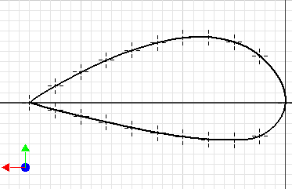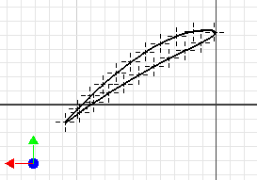
Two profiles and reference points specified(example above: NACA9440 and NACA6410 31° twist).
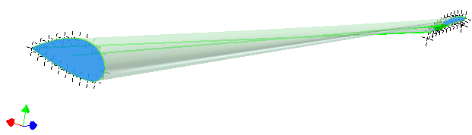
The cutting process. Starts at the reference point and ends move in same direction. The software controls the movement of wire fix points so they will be at the same respective place at any given time during the process.
The software developement will start when building phase is finished and the description above can change subject to software and programming limitations.

7. Shipping instructions
- Remove the wire and motors.
- Fix the bottom of the machine to a pallet using thin steel cable at six places as shown in red in image below.
- Put the wire and motors in a separate box and fix it to the top of the pallet inside the machine frame.
- Fit a wooden box over the machine and fix it to pallet.
- The wooden box has to be strong enough to support a pallet that is stacked on top of it.
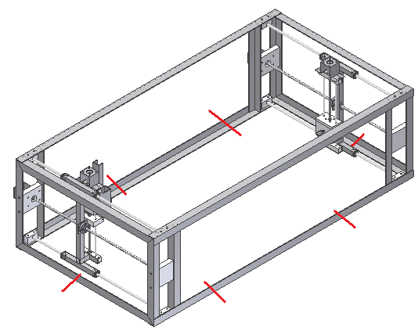

8. Maintenance and safety issues
With time it is expected that the machine precision will deacay due to wear in plug bearings. In that case it is relatively easy to fabricate new ones and swap them. Fatigue in hot wire will probably cause it to fail after random time in service. Increased pretension will cause shorter lifetime of wire. On a larger time scale, wear or corrosion(if in a corrosive environment) can cause backlash or reluctance in leadscrews and nuts. Metal fatigue or overloading may cause the spring to fail eventually. Wear and fatigue can cause the stop screws in the motor coupling to create a kerf on their corresponding shafts which leads to backlash and loss of precision. To allow for easy maintenance the individual components of the machine are designed to be easily dissasembled. The shape of each component is also designed to be relatively easy to fabricate so swapping in new, custom made ones should not be a big problem.
During operation a number of safety issues have to be addressed. The most important is that ventilation needs to be ensured before starting process due to toxic fumes that will spread out from the machine. Electric source must be turned off at least one minute before removing foam after operation of machine to prevent burning and electric shock. Useage of safety gloves is recommended as wire temperature can reach high levels(+200°C).

9. Current status of project
Mechanical design phase is finished, leadscrews and motors are in order and expected to arrive within 30 days. Bill of materials has been created and we reckon that gathering of material will not be a time consuming process. Software developement can start asynchronously with the building phase, although it cannot be finished until the machine is ready for testing.

10. Summary
During the design phase, the machine has been visualised, meeting the goals stated initially by the costumer, function-and budgetwise. By applying axiomatic design methology to the problem, a realistic solution based on tests and preacquired design principles has been developed to the point where fabrication can begin. Workplans, along with bill of materials and transition documentation ensures a smooth transition to whoever will continue to work on the project.

______________________________________________
Fannar Andrason

______________________________________________
Kristján Orri Magnússon

______________________________________________
Sveinn Haukur Albertsson

11.Appendix 1 - Workplans

