Háskólinn í reykjavík
CNC Foam cutter
Tölvustýrður frauðplastskeri.
The CNC foam cutter project was requested by the UAV lab at RU. The purpose of the machine is to cut out wing profiles for small ornithopter wing design research. The design part of this project was undertaken by students of the class Hönnun 1013. The construction and refinement was undertaken in this summer project, under the supervision of Dr. Joseph Timothy Foley.

Final report
Fannar Andrason (RU) Sveinn Haukur Albertsson (RU) Luis Ignacio Huete (RU-UC3M)
Advisor: Dr. Joseph T. Foley
12/9/2011


Contents

1. Motivation and Methodology 6
2. Design 7
2.1 Frame structure 7
2.2 Movement Axis 8
2.3 Tensioning Mechanism 8
2.4 Software Design 9
2.4.1 Motivation 9
2.4.2 Design 10
2.4.3 Algorithm 10
3. Usage description 12
4. Preliminary tests 13
5. Maintenance and safety issues 14
5.1 Assembling 14
5.2 Adjusting 14
5.3 Inserting hotwire 15
5.4 Lubrication 15
5.5 Safety issues 15
6. Summary 16
6.1 Testing 16
6.2 Challenges 17
6.3 Achievements 17
6.4 Future work 17
7. Appendix 1 – Workplans 21
8. Appendix 2 - Bill of materials 23
8.1 Task List. Error! Bookmark not defined.
8.2 Bill of Materials 24
8.3 List of vendors 24
9. Appendix 3 – Structural fabrication 25
9.1 The Frame 25
9.2 Horizontal sliders 25
9.3 Various plastic parts 26
9.4 Vertical sliders 26
9.5 Motor connection and bracket construction 27
9.6 The construction of hotwire connections and tensioning devise 28
9.7 Inserting base plate 29
9.7 Brackets for end stops where made and end stops mounted on 29
10. Appendix 4 – Electrics 30
10.1 Electrical diagraph 32
11. Appendix 5 – Programming 33
11.1 G-code 33
11.2 Pseudocode 34
11.3 Sequence diagram 35
11.5 Machine set up 36
11.6 Specifications 36
12. Appendix 5 - Shipping instructions 37
13. Appendix 6 – Drawings 38

Figures
Figure 1. A Foamlinks(tm) hotwire cutter with cantilevers. (Image from foamlinks.com) 7
Figure 2. Our foam cutter design. The box frame gives more stiffness than the cantilever design. 7
Figure 3. The Y-slider(right) slides into the L-profiles of the X-slider(left) and is bolted into place. The Y-slider is made from aluminum box profile with POM plastic plug bearings for electrical insulation, good friction qualities, and ease of press fitting. 8
Figure 4. The initial spring mechanism design. The spring attachment shaft can be placed in multiple slots, milled in line down the profile. (not shown in this image). 6
Figure 5. The original motor mount design for the Y-slider 9
Figure 6. Final design of the foam cutter 11
Figure 7. A close-up view of slider assemblies(left). The spring tension mechanism is attached (right). 11
Figure 8. Two profiles and reference points specified (example above: NACA9440 and NACA6410 30deg twist) 12
Figure 9. The cutting process. Starts at the reference point and ends move in the same direction. The software controls the movement of wire fix points so they will be at the same respective place at any given time during the process. 12
Figure 10. Terms used in the horizontal movement stage. 12
Figure 11. Test cylinders from speed tests 14
Figure 12. NACA 0040 successful cut. 18
Figure 13. NACA 0020 successful cut. 18
Figure 14. Decomposition block diagram. 22
Figure 15. Frame TIG welded, then washed with acid. 22
Figure 16. Frame assembly. (Sveinn pictured) 23
Figure 17. Vertical movement components 23
Figure 18. Original motor mount. 24
Figure 19. Final design of the motor mounting brackets. Vertical movement (left), horizontal movement (right) 24
Figure 20. Finished CNC foamcutter prototype. 27
Figure 21. Tensioning device and custom built end-stop 25
Figure 23. Wooden base 29
Figure 22. Hot wire connections at separate ends. Hotwire is clamped between two stop screws (grubs). 26
Figure 24. Vertical end stop (left) and horizontal end stop (right) 27
Figure 26. Alliigator clips attached to hotwire (left), transformer mounted (right) 31
Figure 25. Electrical control system for the foamcutter 28
Figure 27. Final wire routing used plastic spiral tubes for protection and better aesthetics. 29
Figure 28. Simplified wiring diagram of CNC foam cutter 32
Figure 29. General program flow 35
Figure 30. Box mounting points for shipping the device 37
Figure 31. Overview 3-view drawing. 36
Figure 32. Exploded view of X-slider and Y-slider 37
Figure 33. Closeup drawing of hot-wire tension and manipulation system 38

1. Motivation and Methodology
The CNC foam cutter project was requested by Leifur Þór Leifsson, head of the UAV lab at Reykjavik University. He needed to manufacture wing profiles for research and testing of small ornithopter wing design within a budget of 200.000 ISK. For comparison a similar (yet not fully comparable) device can be bought from the company Foamlinks™ in Poland starting at 4.000 USD (460.000 ISK in June 2011). We created list of functional requirements (FR) using axiomatic design mythology from a meeting with Leifur:
- Cut airfoils out of foam for ornithopter design research.
- Wing profile must be able to vary with span.
  - Twist, variable camber, sweep etc.
  - Specified tolerances +/- 0,5 mm.
- The requested dimensions are 50 cm wide, 25 cm high and 1 m long.
- Make the machine cheaper than if imported.
- Adjustable size to meet varying customer needs
To be able to satisfy all the requirements, we made a list of design parameters (DP) to consider for designing a solution:
- Use a pretension hot electric resistance wire (i.e. NiCr) to cut through foam pieces
  - Each end of wire fixed to a slider that can move in the plane perpendicular to the direction of wire (hereafter called X-Y plane).
  - 2 sets of 2 stepper motors drive lead screws to change position of wire fix point in X-Y plane.
- Wire point on each end must be able to move independently of each other and maintain a straight line
  - Exposed wire must elongate/shorten
  - Pretension maintained at 150N to prevent inconsistent kerfs.
- Dimensioning of frame design to allow for specified values
  - Box frame to maintain alignment of X-Y planes
- Use affordable, easily-available parts
  - Standard profiles for structural components/subassemblies.
  - Stepper motors for efficient, inexpensive open-loop design.
  - Cheapest available lead screw chosen to minimize cost, without sacrificing precision and durability (compared to threaded shaft).
- Bolted frame long axis members can be swapped out to change size

2. Design

2.1 Frame structure
From the beginning of the project, we realized that prevention of bending and jamming was the key aspect for a good design. Correct center of action placement and application of Saint Venant’s principle on bearings and slider surfaces avoid these problems. Saint Venant’s principal of 3-5 characteristic dimension lengths between deformable elements ensures proper sliding. To meet tolerance specifications, the frame and components should be rigid. We decided upon a box frame instead of Foamlinks™’ two cantilevers, which would require more material.
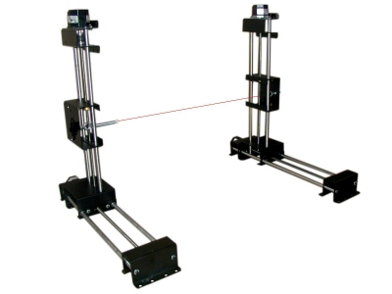
Figure 1. A Foamlinks(tm) hotwire cutter with cantilevers. (Image from foamlinks.com)

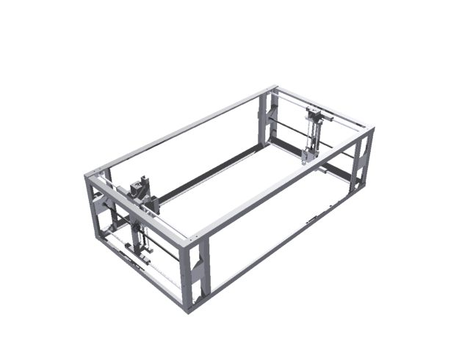
Figure 2. Our foam cutter design. The box frame gives more stiffness than the cantilever design.

2.2 Movement Axis
Requirements for the slider assembly demand precise fabrication. To achieve the goal of jam and deflection prevention, considerable effort was put in the design process. Axiomatic design’s DP the mechanism had to be broken down into parts that can be assembled and disassembled easily.
To achieve a smooth travel, the bearings for the X-direction slider are made of POM plastic and are a plug type for easy manufacturing and assembly. They are plugged in each of the profile end and have 0.1mm clearance from the leader rod. Their length is kept at minimum to reduce friction. The center of action, i.e. the location of the lead nut, is located at the center of friction for the slider to achieve zero sums of moment loads. This middle lead screw also acts partially as a bearing surface, halving the Saint Venant’s characteristic length. Other loads (from the wire) are insignificant lessening the risk of jamming. The same principles are applied to the Y-slider with the consequent design result that can be viewed below.
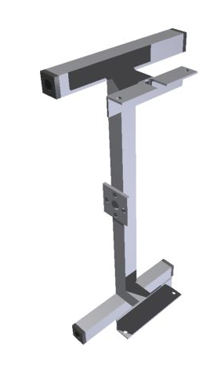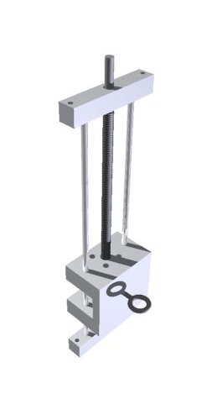
Figure 3. The Y-slider(right) slides into the L-profiles of the X-slider(left) and is bolted into place. The Y-slider is made from aluminum box profile with POM plastic plug bearings for electrical insulation, good friction qualities, and ease of press fitting.

2.3 Tensioning Mechanism
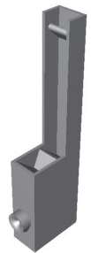
To ensure tension, while allowing the wire to elongate and shorten, a spring mechanism is mounted to one of the slide assemblies. The wire goes through a rounded leader, then on a steel shaft with a diameter of 8 mm. This shaft changes the direction of the wire to point it upwards. There it connects to a spring connected to a shaft for adjusting the pretension of the wire. The mechanism is pointed upward because other directions limit the field of travel and to prevent it from sticking out of the side of the machine.
As the motor mounts do not take any load other than torque from the motor it can be fabricated out of 1 mm thick sheet metal bolted to the frame with threaded bars. The mount is although subject to testing and further development if proven to deflect to that degree that it affects machine precision due to torque load.
Figure 4. The initial spring mechanism design. The spring attachment shaft can be placed in multiple slots, milled in line down the profile. (not shown in this image).
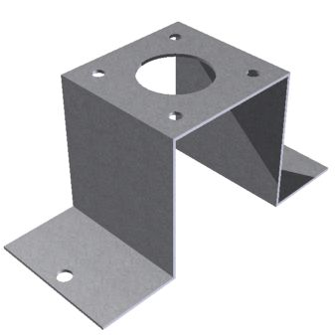
Figure 5. The original motor mount design for the Y-slider
When choosing mechanism to translate turning motion into linear motion, Occam‘s razor suggested that the screw and nut method would be more suitable than belts or chains. We decided to rule out common threaded shaft because it degrades quickly; it is commonly used for low-cost short lifetime applications. A ball screw is very expensive, so we decided as a budget compromise to use lead screw with a rounded thread, yet satisfying our precision requirements. The chosen lead screw has a diameter of 12 mm and pitch of 4 mm.

2.4 Software Design

2.4.1 Motivation
We needed to control a precision machine able to manipulate two mechanical hands holding a hot wire able to cut blocks of foam into complicated shapes. Due to our choice of MakerBot controller electronics, the software element missing is an application that can generate G-code (explanation in appendix 5) able to move the two hands synchronously to create these figures.
The state of art has several programs that translate drawing formats (for example the ones you can make in AutoCAD, SolidWorks, etc.) to G-code in X, Y, Z coordinates. The problem comes when merging two figures using 4 coordinates, 2 per side of the machine. In our case we use X, Y, A and B.
In this project the machine takes the G-code file generated by the program that takes the separated G-code files extracted from a converter like ReplicatorG (in this only the perimeter of the figure is needed), or “ace converter”. Programs like NC-plot can be used to plot G-code to ensure the code has no flaws or incorrect commands.
Once the two figures in 2D are mixed in our program, the machine can move the hands synchronously.

2.4.2 Design
In the early steps of the project the idea was to make a complete program that would convert the drawing format to G-code for each side of the machine then synchronizing cutting speed. But after searching documentation and other projects related to it, we realized that a mature implementation of the idea would extend beyond the timeframe for this project. We discovered that many file formats could be converted to G-code. At this point we started looking for other solutions. In later stages of the project the idea of trying to modify a freeware of the Unicorn project (Scribbles) was taken into account. This program can be modified to create a convertor from scratch from DXF files.
The final solution proposed was to create a program that would take G-code as input of two figures with X and Y coordinates. Merge and changing them from X and Y to A and B coordinates, and using interpolation to adjust the cutting speed of one profile figure so they finish at the same time
The program was made in Java which is a powerful object oriented programming language that makes the program easy to structure in different blocks and gives the possibility to create a user interface that improves the usability of the program. This can be made with “Netbeans” or “Visual Studio”.
The program created the G-code file that must be run in the ReplicatorG. We use Makerbot (tm) Thing-o-matic, adapted to our requirements modifying the machine called Experimental.
When we take the input files there are some considerations:
- The figures must move in the same direction, and they must start from similar positions.
- These files have different timing and feed speed.
- There are end-stops only in the upper limits, so figures must conform to the size of the machine.

2.4.3 Algorithm
- Read both input files and find the proportion of difference in timing.
- Change file 2 to adjust timing and change coordinates.
  - We take into account the different lengths in each profile´s perimeter and adjust the feed speed so they finish at the same time.
  - If we consider that both figures are drawn in the same way (clockwise or counterclockwise) they will merge correctly.
  - If the profiles face opposite directions we must mirror the coordinates.
- Mix both files changing coordinates so each line of the G-code contains X, Y, A and B coordinates.
- Write the output file.
  - Reset the position of the steppers.
  - Write the output G-code.
  - Go to the origin of coordinates.
- Close the files.

Figure 6. Final design of the foam cutter
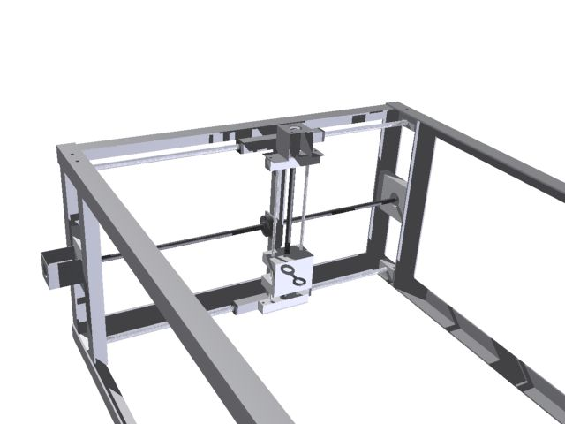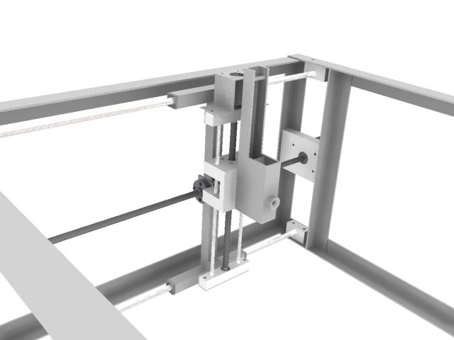
Figure 7. A close-up view of slider assemblies(left). The spring tension mechanism is attached (right).

3. Usage description
A piece of foam is inserted from the top and slid until one corner flushes with a fixed setsquare. The user then defines the two wing profiles that he wants to loft between. He also has to specify corresponding reference points for both profiles (e.g. location of max camber), which will be the starting point for the cutter. Finally, he specifies the length of the wing. The software then extrapolates one of the profiles to get the correct shape at the end of the wing section. The shorter length of wing specified, the larger the projection has to be. The software then calculates the distance the wire fix point has to travel to cut out the larger profile, defines the movement speed there as 4 mm/s and scales down the movement speed of the other end to ensure the same cutting time at both ends. That will ensure correct lofting.
Example:
Reference points
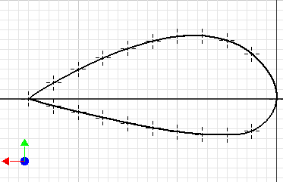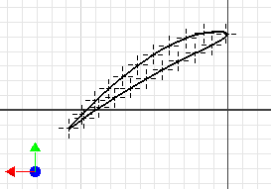
Figure 8. Two profiles and reference points specified (example above: NACA9440 and NACA6410 30deg twist)
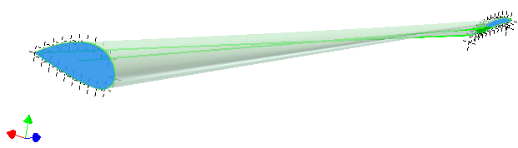
Figure 9. The cutting process. Starts at the reference point and ends move in the same direction. The software controls the movement of wire fixed points so they will be at the same respective place at any given time during the process.

4. Preliminary tests

Preliminary test using a heated wire indicated that a movement speed of 4 mm/s while applying 35 W to heat the wire would be ideal (the kerfs will be consistent enough to meet the specified tolerances). A qualitative test was performed on the stepper motor. It indicated that the step input has a range up to 700 Hz and with 24V as input voltage it gave sufficient amount of torque. The steppers have a precision of 1,8° per step, which means that the distance traveled per step, d, is:
$$d=\frac{1,8}{360}∙4=0,02 [{mm}/{step}]$$
Also, as the upper limit of rotational speed is defined by the upper limit of step input frequency, the maximum speed of movement, v_{max} is:
$$v_{max}=\frac{700∙1,8}{360}∙4=14,0 [{mm}/s]$$
As the distance per step more than satisfies our specified tolerances and the maximum speed exceeds our ideal cutting speed of 4 mm/s, no additional gearing mechanism is necessary. Therefore the motors are directly coupled to the lead screws.

5. Maintenance and safety issues
It is expected on the cutter, as with all machines, precision will decay with time. Here it is mainly due to wear in our plug bearings, chosen due to easy fabrication and replacement. Fatigue in the hot wire will cause it to break. Excess pretension shortens the lifetime of the wire. On a larger time scale, wear can cause backlash or reluctance in lead screws and nuts. Metal fatigue or overloading may cause the spring to fail as well. Wear and fatigue can cause the stop screws in the motor coupling to create kerfs on their corresponding shafts, leading to backlash and loss of precision due to play. To allow for easy maintenance each component is designed for easy disassembly. The shape of each component is also designed to be relatively easy to fabricate with access to a standard machineshop similar to the one we have at Reykjavik University (containing a vertical mill and a lathe).

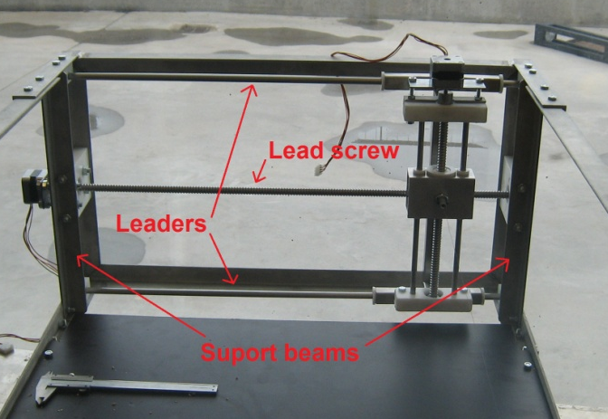
5.1 Assembling
Figure 10. Terms used in the horizontal movement stage.
To disassemble the horizontal slider you must start by removing both support beams. Then you have to move the horizontal slider to either side of the machine, remove the plastic bracket that holds the lower leader on the other side and finally drag the leader out. When you have done that you can remove the lead screws bearing seats and the upper leader and easily disassemble the rest of the assembly
Disassembling the vertical slider is a fairly easy process. Remove the bolts that hold the plastic bracket in place and slide the whole vertical set out. Remove either lead screw nut or motor connection to disassemble the vertical set. It may be necessary to heat the motor connector with a blow torch to be able to screw them of the lead screws because they were assembled with thread glue; be careful not to melt the plastic in the surroundings.
It is convenient to remove stepper motors before disassembling either vertical or horizontal movement. You start by loosening the stop screw that fixes the motors to the motor connections. Then remove motor mount bolts to either frame or bracket and pull the motor straight out. Be careful to avoid breaking the wires while you remove the motor.
To assemble the machine you reverse these steps. Once assembled, you must adjust the machine according to the following instructions.

5.2 Adjusting
Synchronizing the leaders and lead screws together for the horizontal movement is a high precision job. The upper leader cannot be adjusted but the lower leader and lead screw must be adjusted to avoid jamming. The lead screw can only be adjusted vertically so you should start by roughly adjusting the height and then adjust the lower leader. The lower leader can only be adjusted horizontally and needs to be adjusted very carefully. Then you fine-tune the lead screw and finally tighten all bolts. It is convenient to disassemble the lead screw nut from the horizontal beam and slide it back and forth to recognize any sticking.
The only adjustable part of the vertical movement is to twist the plastic brackets on the top and bottom of the beam; it should always be performed when the vertical movement is at the machine.
The motors need to wobble a little bit and they should be slightly loose to avoid overconstraint. The brackets are designed to allow some movement in non-critical directions to prevent damage to the bearings.
The end stops can be easily adjusted. You simply loosen the bolts, and slide them to a position where vertical and horizontal sliders can reach the end stops but cannot crush them.

5.3 Inserting hotwire
Inserting a new NiCr cutting wire can be tricky the first time. First you locate the slider on each side so the distance between them is as short as possible. Then you start by inserting the wire through the hole on the tensioning side. The wire has to go through the hole, around the bolt that is mounted through the bracket and pointed up towards the spring. Then it is best not to have the wire connector connected to the spring and attach it to the wire before hanging it on the spring. Have the spring located in the lowest slot, cut the wire in length and fasten it on the other side. Please keep in mind that the maximum variation between sliders is 12 cm. If the spring is located in the lowest slot when replacing the wire the wire may not be extended when connecting it to the other side to avoid wire rupture.
Eventually wire tension can be adjusted by placing the spring in a higher slot. It is important not to have too much wire tension, because the stepper motors can easily be overloaded causing them to stop or skip steps, possibly ruining the foam piece.

5.4 Lubrication
We have tried several lubricants during the building process to lubricate both leaders and lead screws. We discovered that most effective lubricate is Teflon spray (PTFE spray). Because both sliders and lead screws are made of metal and bushings are made of POM plastic you may not use traditional motor or gear oil because they tend to dry up and in some cases melt the plastic. WD-40, transmission oil or cutting oil cannot be used for the same reasons.

5.5 Safety issues
During operation a number of safety issues have to be addressed. The most important is that ventilation needs to be ensured before starting process due to toxic fumes that will spread out from the machine. The electric transformer must be turned off at least one minute before removing foam after operation of machine to prevent burning and electric shock. Usage of safety gloves is recommended as wire temperature can reach high levels (+200°C).

6. Summary
Figure 11. Test cylinders from speed tests
During the design phase in the spring semester, the machine had been visualized, meeting the goals stated initially by the customer, function-and budget wise. By applying axiomatic design methodology to the problem, a realistic solution based on tests and design principles had been developed to the point where fabrication could begin. Work plans, along with bill of materials and transition documentation ensured a smooth transition to whoever would continue to work on the project.
We find the overall design to be good except for minor issues. The I-beam and the mounting system for the horizontal leaders and lead screw redesigned. We preferred the design of the vertical movement, because the mounting bracket is in one piece. Designing it that way is less error prone, mainly because it almost needs no adjusting and is less likely to become overconstrained. To be able to use that design on the horizontal movement, the I beam would have needed to be fully redesigned, mainly because a welded part will always bend a little, which would be unacceptable if both ends were completely constrained.

6.1 Testing
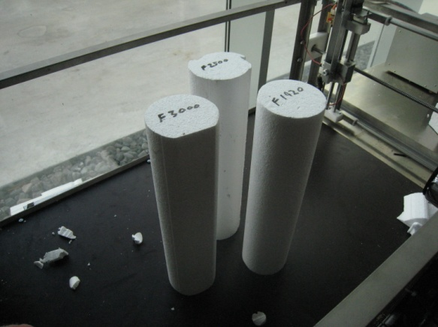
We did preliminary tests to figure out the ideal cutting speed in terms of wire heat. We also discovered that by using thinner wire we were able to cut with more precision and less tension was required to keep it straight for accurate kerfs.
Preliminary test for wire heat was done with 0.8mm thick NiCr wire and a variable power source. When doing similar test with the thinner wire we recognized that much more power was needed to get similar heat because the thick wire measured 4,4Ω where as the thinner wire measured 40 Ω and the variable power source simply did not deliver enough power. To be able to choose a constant power source joule´s law applied was applied to find out the amount of voltage and current needed to heat the wire.

Joule´s Law $Q=I^{2}*R*t→\frac{Q}{t}=I^{2}*R=P$
When testing the thicker wire we found out that 11 V and 3 A gave sufficient power to cut the foam. By applying joule´s law we recognized that 40 V would be the minimum amount of voltage to cut foam with the thinner wire.
After acquiring the constant power source, experiments were performed to decide the optimum cutting speed based upon surface smoothness.

6.2 Challenges
Although small problems occurred in the fabrication process, the overall build eventually finished. Minor changes were made in the process such as motor mountings were redesigned, hotwire mounting and tensioning system was fully designed, the frame can be partly disassembled and the most radical change was that the vertical slider was fully redesigned. We believed that the initial design of the vertical slider would not be reliable, due to risk of jamming. The original design was more challenging to manufacture for similar performance.
Although we changed the motor mounting bracket we were not completely satisfied with the outcome. The motors are slightly overconstrained which limits their output power. When we designed the motor connection we were avoiding slack, because it would have affected the precision of the machine. After building the machine believe the motor couplings and mount need to be further refined.
When we were working with ReplicatorG we realize that it didn’t recognize A, B axes. So to solve the problem we changed the Thingomatic.XML file to use the experimental machine including A, and B coordinates.
During the implementation of the program we ran into few problems.
- Different feed speeds in lines of G-code. To solve the problem we had to split the longest sentence to adjust to the lines of the other profile.
- The original program had extra parameters Z, U and V, which are used in 3D printer and are useless in our application.
- In the machine, X and A go in the same direction, but Y and B go in opposite direction. We had to translate the coordinates thinking on this. So the program modifies the sign of B coordinate.
- Starting point is closest to the end stops. Put the lines before this point at the end.

6.3 Achievements
This summer we managed to build a functional foam cutter that can be used for making i.e. various types of wing profiles for researching and almost anything that fits within its dimensional limitations with specified tolerances. The only drawback is the software part has not been fully developed. The first step is to create a drawing on a DXF format and convert it to G-code. Our software adjusts this G-code so that our MakerBot electronics can parse it. We are able to cut homogeneous wings, which will be generalized to non-homogenous later.
Although overall cost has not completely resolved (because one invoice that has not been accepted) we are certain that the cost will be within limits. Our machine was tailor made for the consumer with no comparable machines existing on the market. No comparable machine with this level of performance exists within our budget. In addition, our machine can be resized to cut larger wing sizes if necessary.

6.4 Future work
As stated earlier there is work left to do in the software part for example adjusting the problem of different feed speed, implement a more user-friendly interface and changing the firmware so it can recognize all four end-stops. The hardware part is finished. Later when we acquire more experience with the machine some mechanism needs to be developed to place the foam in parallel position and if necessary attach it to the base.
There is an interesting option that can be added to the machine which is the option of a rotational axis in the center of the base plate which ads the possibility to use the foam cutter as a lathe.
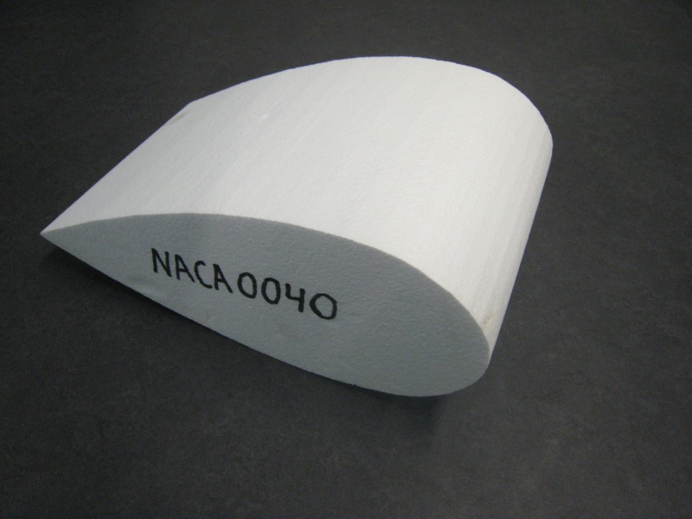
Figure 12. NACA 0040 successful cut.

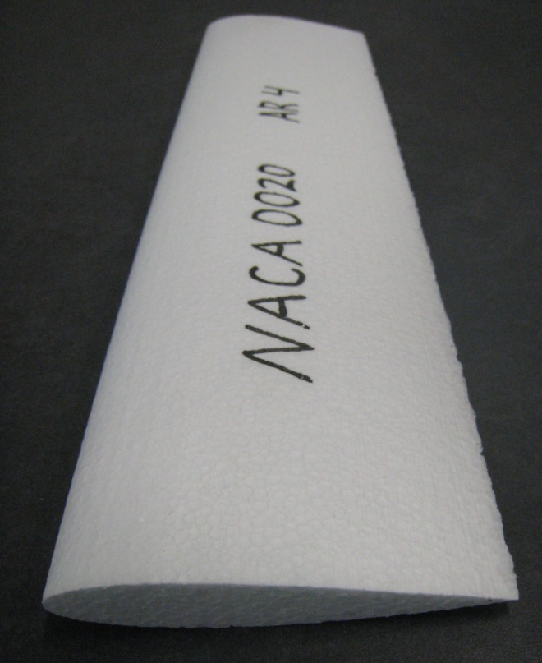
Figure 13. NACA 0020 successful cut.

__________________________________
Sveinn Haukur Albertsson

__________________________________
Fannar Andrason

_________________________________
Luis Ignacio Huete

_________________________________
Joseph Timothy Foley (Advisor)

7. Appendix 1 – Workplans

The foam cutter project was a collaborative effort with another RANNIS project. Fannar Andrason and Luis Ignacio Huete were assigned for this CNC foam cutter project. Sveinn Haukur Albertsson was registered for “Prototype autonomous flapping-wing unmanned air vehicle with high maneuverability” research. The purpose of the foam cutter was to cut out wing profiles for wing research for the ornithopter prototype, so the collaboration was an obvious choice.
Luis was to focus on tests and do experiments with the machine. Sveinn and Fannar decided to collaborate with the structural fabrication. A task list had been made synchronously with the design process in the spring. Due to changes in the collaborators scope it needed to be updated. Rough schedule was made and it stated that the structural fabrication of the foam cutter would finish at the end of June. Due to delivery delay of the lead screws we were delayed for 3 weeks, so we finished in the beginning of August.
To keep track of the work process, weekly meeting were held with our advisor Dr. Joseph T. Foley to discuss last week’s work and next week’s assignments and to keep everyone up to date.
On the following page we reveal our project management plans developed from initial work in Hönnun, showing the entire project from the design to completion. Our Axiomatic Functional Requirements developed into Design Parameters, giving clear specifications for the design. These Design Parameters were decomposed into the block diagram (Figure 14). Our team examined each of these blocks to make estimations of time for the fastest, slowest, and most likely amount of time, guiding our schedule/task list (Table 1).

7.1 Task list
Table 1. Task list
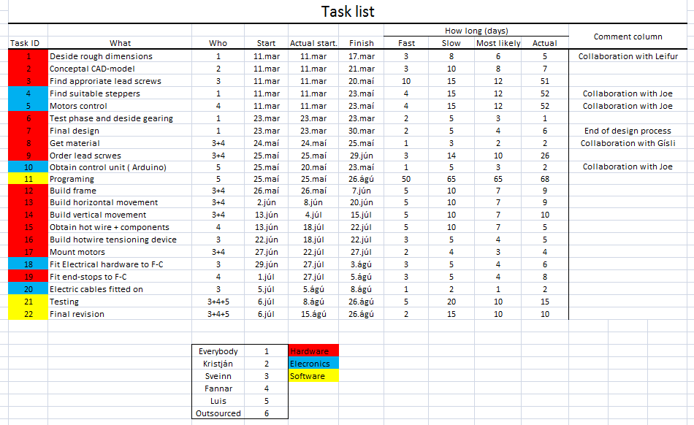

7.2 Decomposition block diagram
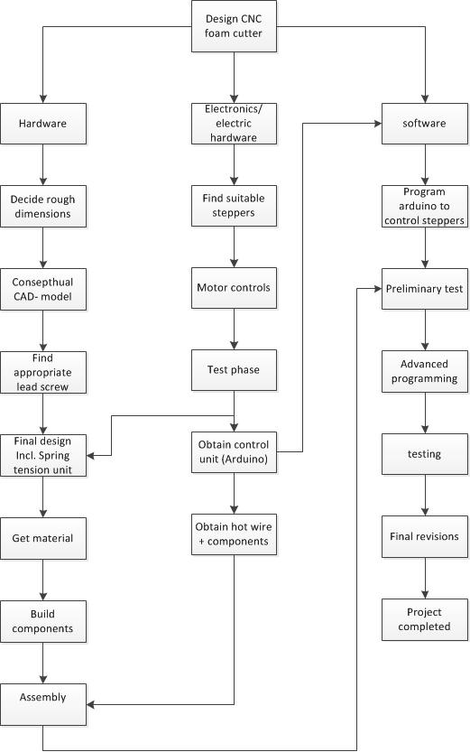
Figure 14. Decomposition block diagram.

8. Appendix 2 - Bill of materials

We had already done most of the design work and made a bill of material (BOM) in a design class last spring semester so collecting all the parts and materials we needed was not difficult. We started by consulting with Gísli Freyr (head of the machine shop) to decide from who we would buy the parts and the materials we needed. His suggestions are reflected in 8.2 List of vendors. After getting a quote from various companies we decided to buy most of the steel from Málmtækni and the plastics from Fást. Our BOM can be found in Table 2.
It soon became clear that the most difficult and critical part to acquire would be the precision lead screws with matching nuts. We searched the Internet but could not find a vendor in Iceland with matched set available. We wanted to purchase Icelandic parts whenever possible, as good citizens, so we looked for lead screws in local manufacturing companies. We looked into the tooling required to make them in our shop with an estimated cost would be 80Þ ISK. At the same time, we found a pair of trapezoidal lead screws for a fairly low price from the US at approximately 50Þ ISK. Eventually we found an Icelandic machine shop ISO-Tech offering to manufacture ball-screws for estimated 60 Þ ISK. Their prices were slightly higher than foreign ones but this type of screw has less backlash and lower friction. They also offered to machine the screw ends for our motors and bearings, making them the best choice.
Unfortunately, we are not able completely resolve the final cost because we have not come to agreements with ISO-tech. Our initial quote was 60Þ but the vendor increased the price and did not deliver all the parts nor on schedule. The final cost excluding the outstanding invoice is 122.663, ISK. We were successful in meeting our budget, assuming that ISO-tech is able to honor its agreement.

8.1 Bill of Materials

Table 2. Bill of Materials Table
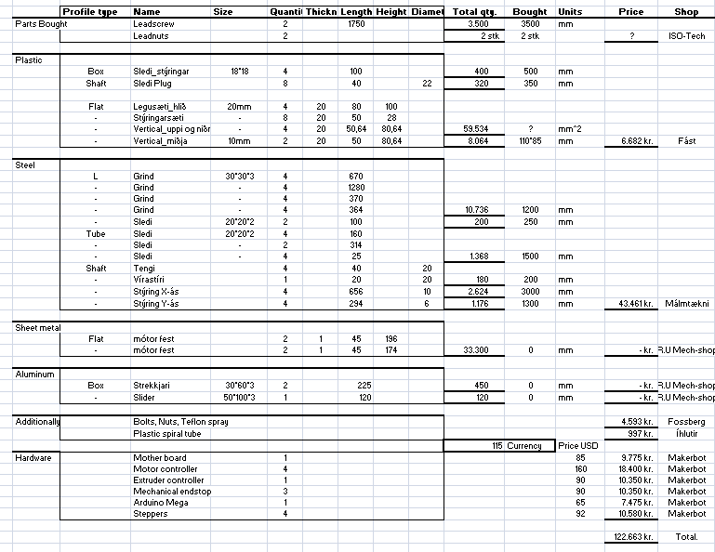

8.2 List of vendors

Makerbot; (URL) http://www.makerbot.com
Málmtækni; (address) Vagnhöfða 29 – (phone) 580 4500 – (URL) http://www.mt.is
Fást; (address) Köllunarklettsvegi 4 – (phone) 587 6677 – (URL) http://www.fast.is
ISO-tech; (address) Dalshrauni 9 – (phone) 555 6200 – (URL) http://www.isotech.is
Fossberg; (address) Dugguvogi 6 – (phone) 5757600 – (URL) http://fossberg.is
Íhlutir; (address) Skipholti 7 – (phone) 511 2840 – (URL) http://ihlutir.is

9. Appendix 3 – Structural fabrication

The structural fabrication started on May 16 2011 in the machine shop in Reykjavík University. The machine shop here in Reykjavík University is sufficiently well equipped for working in metal, so as soon as we received the materials we started building the frame on-site.

9.1 The Frame
The only change that was made from the initial design was that the frame is bolted together on the long axis to be able to elongate or shorten it if necessary. We started out by cutting the L profile bars into lengths and cutting a 45° gradient on the appropriate ends. All welds were done with a TIG welder, using appropriate clamps and fixtures for accuracy. After welding we leveled the frame off and drilled holes (Figure 15 left). We drilled the holes after welding to compensate for any initial misalignment or bending in the metal. Finally the frame was cleaned with acid to improve corrosion resistance and surface finish (Figure 15 right).

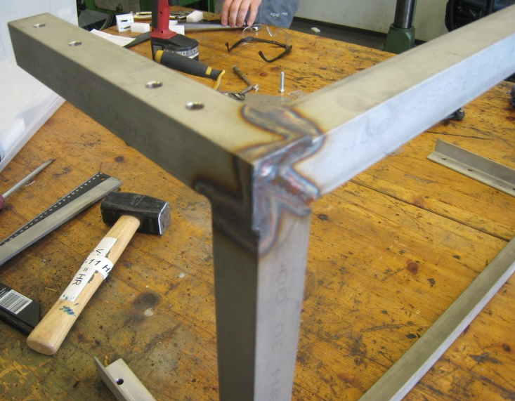
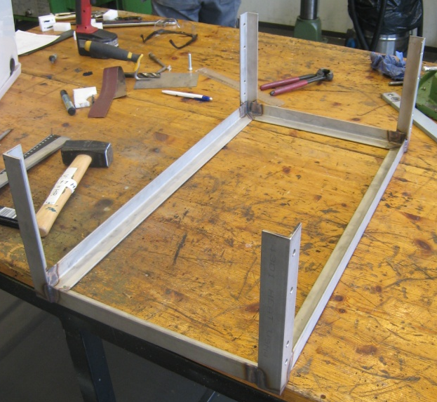
Figure 15. Frame TIG welded and drilled (left), then washed with acid (right).

9.2 Horizontal sliders
After assembling the frame we started building the horizontal movement that we call an I-beam (because it is shaped like a capital I). The I-beams needed to very precise so the horizontal movement would not be overconstrained, creating friction and wear. We initially had problems in that process because the uneven and intense welding heat caused the beam to bend due to internal stresses. We managed to overcome this problem by pre-heating the steel, welding with a lower heat, and not welding all sides in the joint.

9.3 Various plastic parts
Figure 16. Frame assembly. (Sveinn pictured)
Various plastic parts needed to be fabricated for the machine i.e. bushings, bearing seats for lead screws, brackets for movement leaders and brackets for end stops. We decided to make bushings out of POM plastic to keep the friction low. It is also easy to machine precisely. We deliberately made the lower bushings slightly oval to avoid overconstraint.
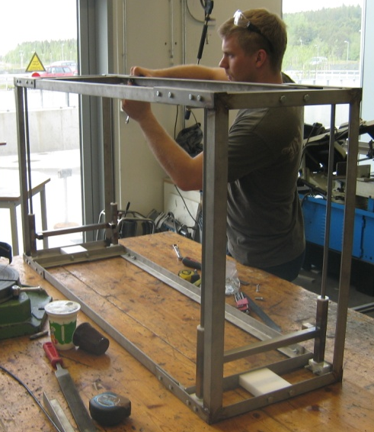
When we finally received the lead screws and the lead screw nuts we were able to continue. The brackets for the leaders and lead screw bearing seats needed to be manufactured to mate smoothly because they were not designed to be adjustable. This was of great concern to us. All plastic mounting parts in the horizontal movement plane were drilled and machined in lengths in the CNC vertical mill to maintain alignment between the holes and attachment surfaces.

9.4 Vertical sliders
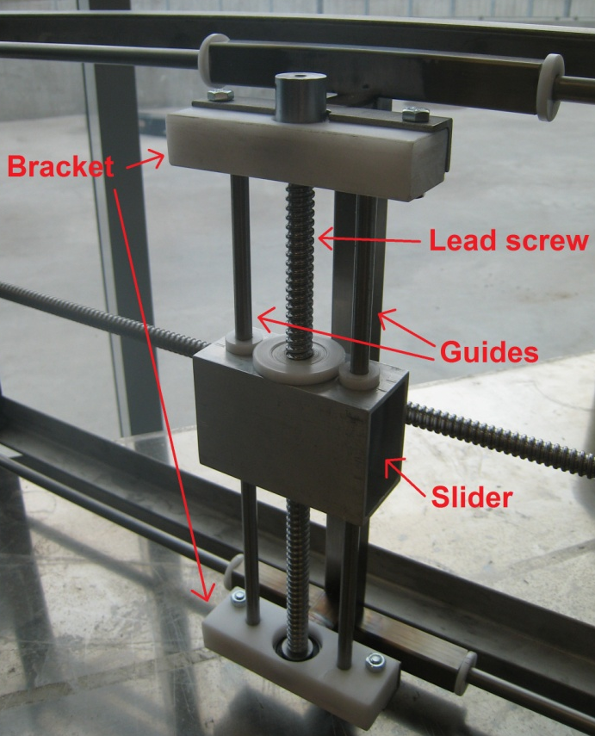
The vertical movement was designed for simplicity, so the position of the guides and lead screw are meant to be adjustable. As before, precision in the alignment of holes and surfaces was very important on both slider and brackets. To get them to properly line up, the brackets were fabricated in the CNC mill. The depth of the bearing seats was determinate by length of the lead screws. The precision of the bushing holes for the bushings is particularly critical, so we drilled them in the mill while using a dial indicator to verify their location. These tactics allowed us to build the vertical sliders with very low resistance and acceptable stiffness. We only were provided two lead screw nuts from the vendor (see 8. Appendix 2 - Bill of materials) but four were needed. We had to cut them in half in the lathe to allow us to continue. Because there was only one flange per nut, we threaded the smaller ends and made small nuts to tighten them on to the sliders. The final assembly can be seen in Figure 17
Figure 17. Vertical movement components

9.5 Motor connection and bracket construction
ISO-Tech provided motor couplings were very similar to the ones we designed. The connector is simply screwed on to lead screws but we used thread-locking glue to make sure that the connectors would not come loose. The connectors did not fit our stepper motors so we made new ones.
Our original motor bracket design was to bend a sheet metal plate like the one shown on the picture but we realized that it would be difficult to build in our uncalibrated bending press.
We eventually decided to fit the motors on to a straight sheet metal plate and fasten it with threaded bars. These threaded bars give us the ability to adjust the alignment of the motor in a way that the original design did not
Figure 18. Original motor mount.

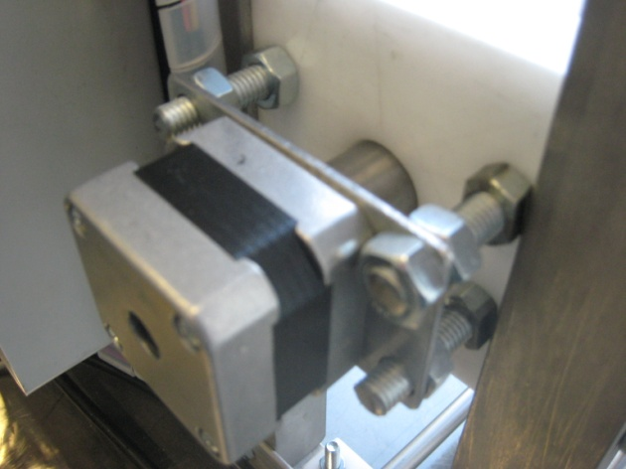
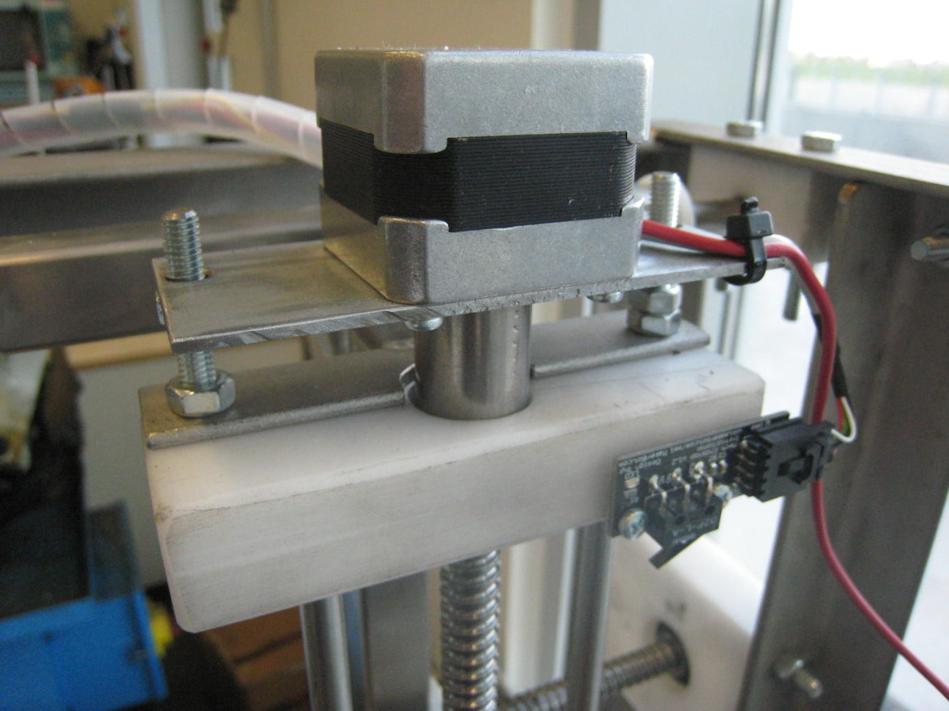
Figure 19. Final design of the motor mounting brackets. Vertical movement (left), horizontal movement (right)

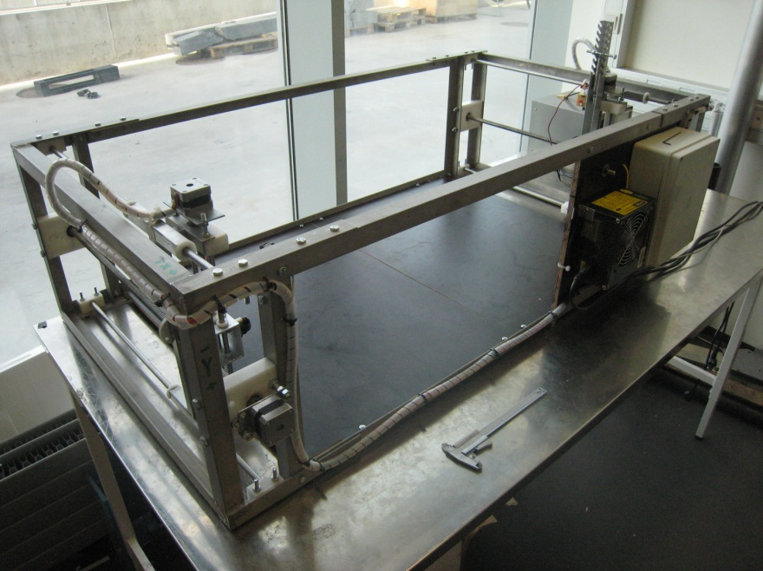
Figure 20. Finished CNC foamcutter prototype.

9.6 The construction of hotwire connections and tensioning device
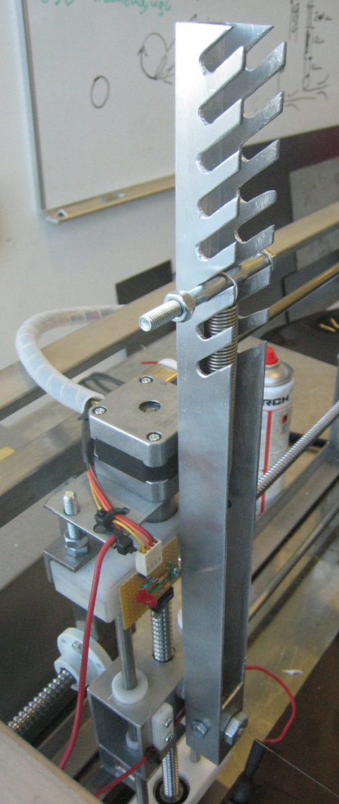
Figure 21. Tensioning device and custom built end-stop
The hotwire manipulator was one detail that had not been completely rendered in the original design. We had a few possible designs and decided to empirically test them. Only one solution consistently kept the wire intact, which was the one chosen.
We drilled through a bolt lengthwise, threaded the wire through that the hole and clamped it between two stop screws with flattened ends. Then we bolted it on the slider
Design Parameter 2 indicated a tensioning mechanism was needed because the distance between the two ends is variable but the wire needs maintain proper tension to stay straight. Too much tension breaks the wire, too little makes inaccurate cuts.
A tensioning system had been designed but modifications were needed. We possessed a tension spring with the right spring constant, so we just had to measure the movement of the wire end to determine the positions and geometry of the tension bracket. We removed the front of a box profile bar and milled angled slots in it for adjustment settings. We drilled lengthwise through a bolt for a wire leader and bolted it on the bottom as mentioned previously. Then we placed a freely rotating bolt through the profile to change the direction of the wire and minimize friction.

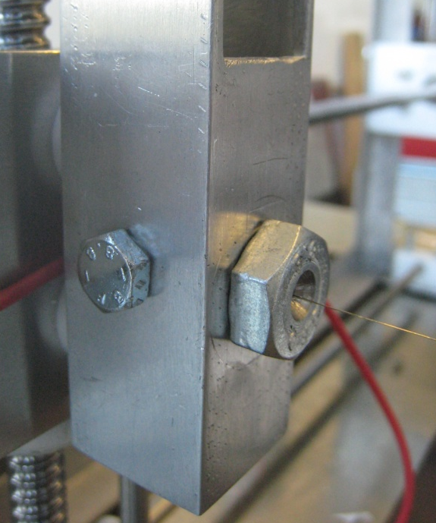
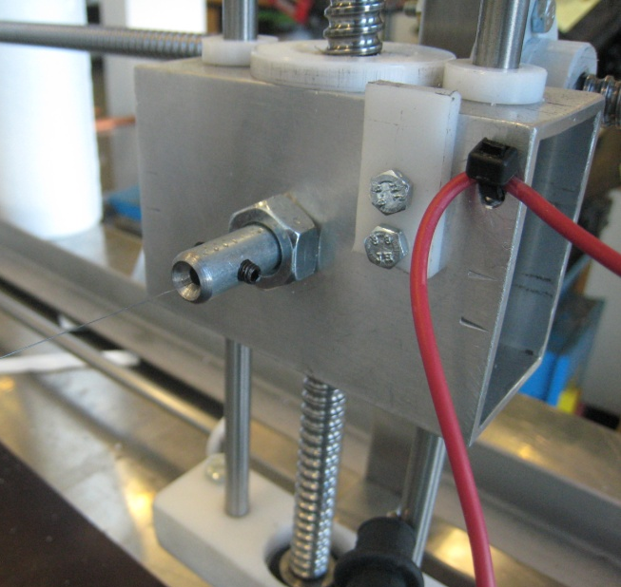

Figure 22. Hot wire connections at separate ends. Hotwire is clamped between two stop screws (grubs).

9.7 Inserting base plate/foam mounting bracket
There were speculations about properly fixturing the foam being cut. We were not sure if the foam would receive any applied tool forces so we delayed that module’s design until we could perform tests. We started by inserting a wooden base plate and discovered that the wire does not apply any forces to the foam at our cutting speeds. We still need a fixture for maintaining the foam’s location due to vibration and wind forces, but are waiting for additional feedback from the customer before doing so. The machine performs sufficiently without additional fixtures for these initial tests.
A wooden mounting plate was also fitted on the side of the machine to be able to attach the electrical control system.
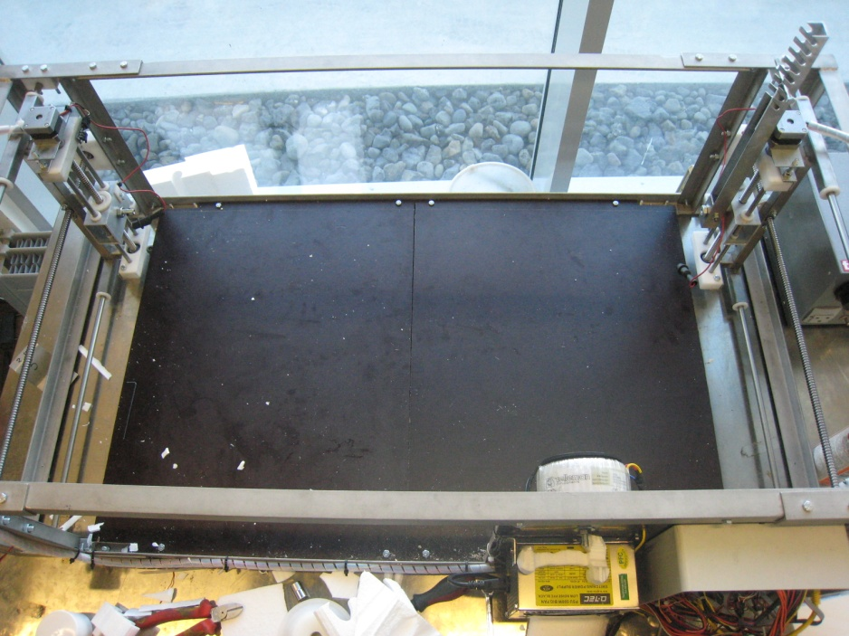
Figure 23. Wooden base

9.7 Brackets for end stops where made and end stops mounted on
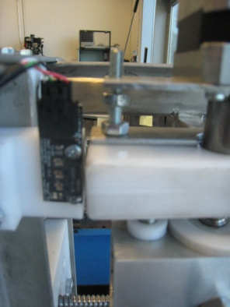
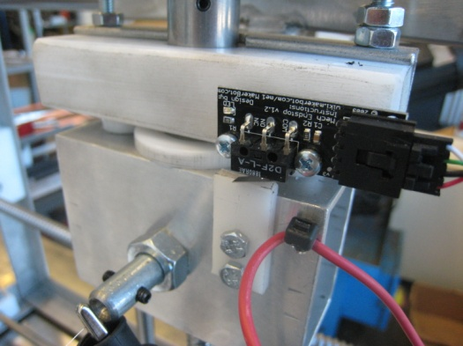
Due to an error in ordering, we received only three calibration end-stops instead of the four needed. With help from Hrannar Traustason (manager of the RU electronics lab) we managed to build a fully functional end stop with parts bought in a local electrical store (Íhlutir). To be able to attach the end stops for the horizontal movement we manufactured small brackets and attached them to the main frame. The vertical end stops were attached to the vertical guide brackets. To get the vertical slider to trigger the end stop we attached a small adjustable plastic strip.

Figure 24. Vertical end stop (left) and horizontal end stop (right)

10. Appendix 4 – Electronics

Our advisor Dr. Joseph Timothy Foley provided us control hardware from MakerBot™ that is usually designed to control a 3D plastic printer. It consists of one Arduino Mega, control board for the heating system, motherboard to control the Arduino mega, four motor controls, four stepper motors and three mechanical end stops. Since we needed four mechanical end stops we needed to build one ourselves as mentioned earlier.
To run the foam cutter you have control the Arduino Mega through USB. The Arduino Mega is attached to the motherboard and the motor controls, end stops and the control board for the heater is connected to the motherboard. The stepper motors are directly connected to the motor controls. Joseph also provided us with a power supply that converts 220 V to appropriate voltage, to power all the components.
After figuring out the voltage needed to heat up our hotwire Hrannar Traustason head of the electrical lab provided us with appropriate transformer for permanent installation. It converts 220 VAC to 48 VAC maintains the wire’s temperature at 200° C. The power supply is connected across the resistance wire generating heat. Our hotwire is a typical resistance wire made of Nickel-Chrome alloy that has good corrosion resistance and high electrical resistance.
The first thing that was done in the electrical process was to connect all the hardware and run the motors to be sure that the system worked properly, before inserting it in the machine.
To be able to fix all the hardware safely onto the machine we started by placing a wooden base on the side of the machine, then all the computer hardware was fitted inside an electrical box and eventually fixed it onto the wooden plate.
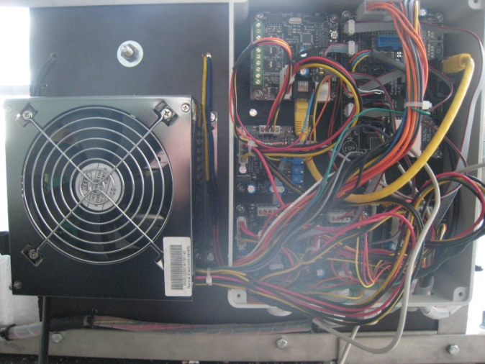
After fitting the stepper motors and mechanical end stops to the machine we needed to extend all the wires to be able to connect them to appropriated plugs. Wires were spliced together and protected with heat shrink tubing.
After connecting the motors and end stops we were able test the machine successfully with only minor adjustments.

Figure 25. Electrical control system for the foamcutter
Crocodile clamps were used to connect the hotwire power source to the hotwire for easy disassembly.

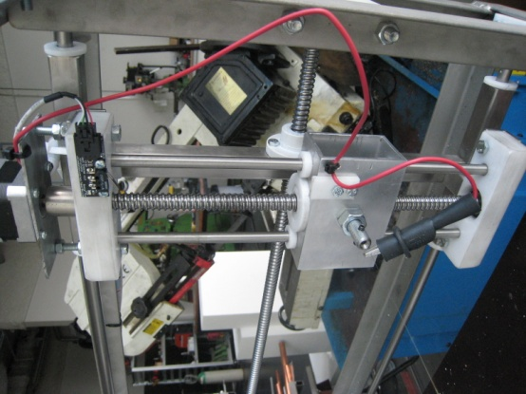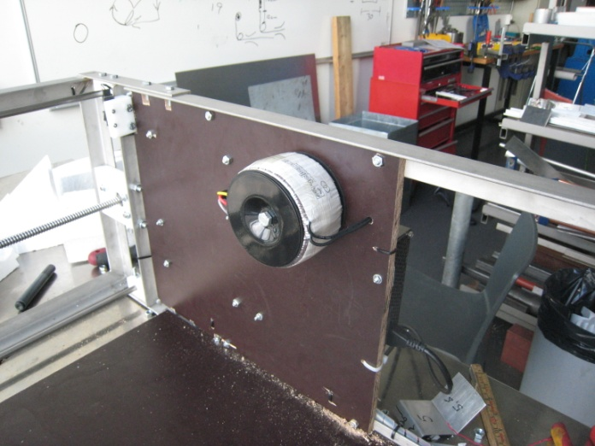
Figure 26. Alliigator clips attached to hotwire (left), transformer mounted (right)

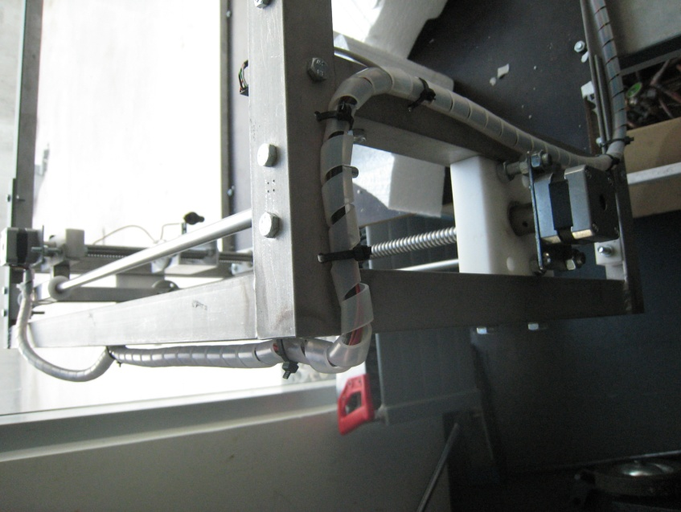

Figure 27. Final wire routing used plastic spiral tubes for protection and better aesthetics.

10.1 Electrical diagram

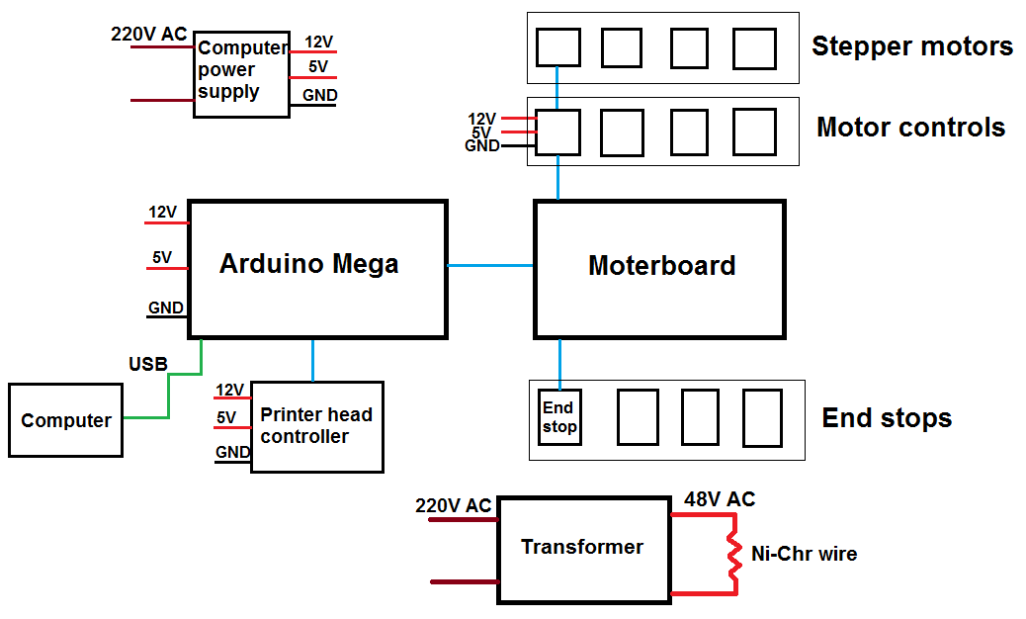
Figure 28. Simplified wiring diagram of CNC foam cutter

11. Appendix 5 – Programming

11.1 G-code
G-code is a semi-industry standard language for controlling industrial robots and tools.
Each sentence/line is composed by a letter code and values. For example:
>>G1 X40.0 Y-30.0 A50.0 B20.0 F2000.0
G1 corresponds to linear interpolation. Depending on the number you will have different functionalities, but in our program we only needed the G1.
X, Y, A and B are the coordinates. Followed by the value you want to move in that coordinate.
F corresponds to the feedspeed, followed by the rate of movement desired.
There are also M-code commands that we will not need except some specific ones, like homing. Homing is the calibration step used at the beginning of a cut to ensure consistency. The X, Y, A, and B, stages go their limit until they detect an end-stop trigger. This sets the origin of the coordinate system for further movement.

11.2 Pseudocode

- public double giveTiming():
open 2 input files (G-code);
While there are lines to read in both files:
Initialize time counter 1 and 2;
While there are lines in file 1:
If there is an F:
Take the quantity after the F and add it to counter 1;
While there are lines in file 2:
If there is an F:
Take the quantity after the F and add it to the counter 2;
Close file 1 and 2;
Return counter1/counter2;

- public String mixFiles(file1, file2)
String outputfile;
While there are still lines in file1 or file 2:
Initialize variables;
Check if there is enumeration code before the instruction;
If the first command is G we compare if not we print the sentence;
We take each token of the sentence of each file and save them in two buffers, changing X per A and Y per B in the second file;
Multiply the second file F value per giveTiming() and mix sentences;
Depending on the difference of timing:
Case giveTiming() == 1 “the same”: put together;
Case giveTiming() >1 “1 file longer”: Split in two parts the 1st file to mix with the first sentence of the 2nd file. Save the rest for the next one;
Case giveTiming() <1 “2 file longer”: Split in two parts the 2nd file to mix with the first sentence of the 1st file. Save the rest for the next one;
Return outputfile;

- public void write Output(string mixed files):
Open output file;
Write heading, initializing coordinates etc.;
Write mixedfiles;
Write ending, going to the origin;

- Public static void main(string Args[]):
If there are enough arguments
Double timing = giveTiming();
String mixedfiles = mixFiles(timing);
writeOutput(mixedfiles);

11.3 Sequence diagram
X:FoamCutter
main (inputfile1.G-code, inputfile2.G-code)
User
giveTiming()
mixFiles()
writeOutput()
Output.G-code

Figure 29. General program flow

11.5 Machine set up
To be able to run the machine you will need.
- Python running environment (2.7.1+)
- Java running environment (SE 7+)
- ReplicatorG (version 25+)
  - Modify the file Thingomatic.xml found in the folder /ReplicatorG/Machines/
<machine experimental="0">
<name>EXPERIMENTAL - Thingomatic - 4 axes</name>
<geometry type="cartesian">
<axis id="x" length="106" maxfeedrate="4000" stepspermm="50.0" endstops="Xmax"/>
<axis id="y" length="120" maxfeedrate="4000" stepspermm="50.0" endstops="Ymax"/>
<axis id="a" length="106" maxfeedrate="4000" stepspermm="50.0" endstops="Xmin"/>
<axis id="b" length="120" maxfeedrate="4000" stepspermm="50.0" endstops="Ymin
</geometry>
<tools>
<tool name="Plastruder MK5" type="extruder" material="abs" motor="true" fan="true" heatedplatform="true" heater="true"/>
</tools>
<clamps></clamps>
<driver name="makerbot4g">
<rate>115200</rate>
</driver>
<warmup>
</warmup>
<cooldown>
(Turn off steppers after a build.)
M18
</cooldown>
</machine>

11.6 Specifications
-The input of the program must be 2 G-code files of each drawing. This can be done with ReplicatorG converting a STL 3D figure into G-code. Unfortunately you will have to manually extract the code in between the tags <perimeter> </perimeter>). Another way is to use a DXF 2D drawing to G-code converter.
-The implementation made of the foam cutter has 4 end stops that calibrate the maximum coordinates of X and A, and B and Y. To prevent the cutter from crashing at the minimum coordinates, we keep track of the current position in the software

12. Appendix 5 - Shipping instructions
- Remove the wires and cables, put them into a sealable bag.
- Remove the motors and couplings, store them in a separate padded box
- Place the electronics box into an anti-static bag.
- Fix the bottom of the machine to a pallet using thin steel cable at six places shown in red in Figure 30
- Put axis to Max or Min and zip-tie them to the frame to hold in place.
- Put the wires, motors, and electronics separate box and fix it to the top of the pallet inside the machine frame.
- Fit a wooden box over the machine and fix it to pallet.
- The wooden box has to be strong enough to support a pallet that stacked on top of it.

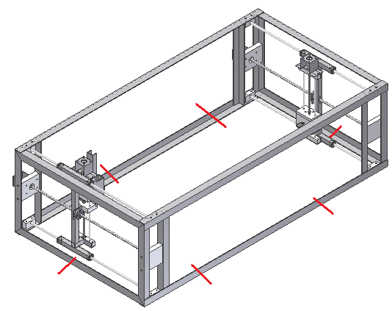
Figure 30. Box mounting points for shipping the device

13. Appendix 6 – Drawings
These drawing show the overall geometries and important components in the CNC foam cutter.
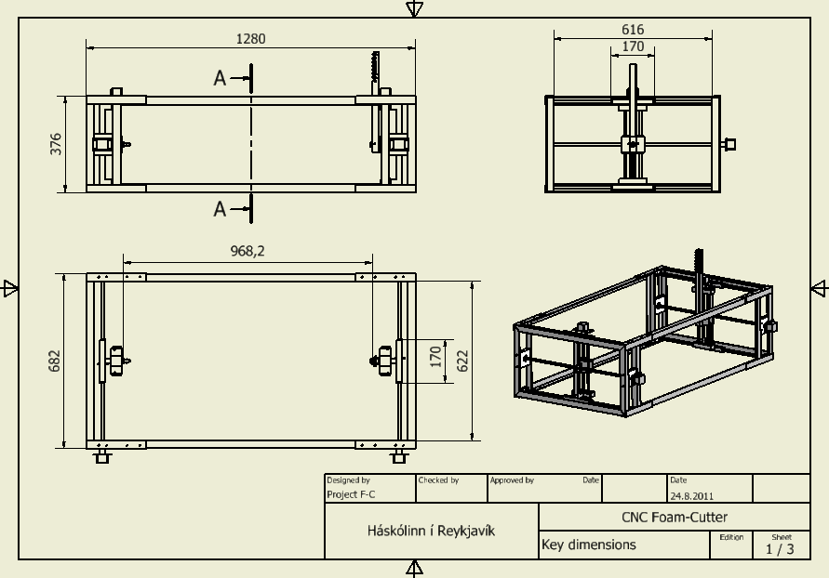
Figure 31. Overview 3-view drawing.

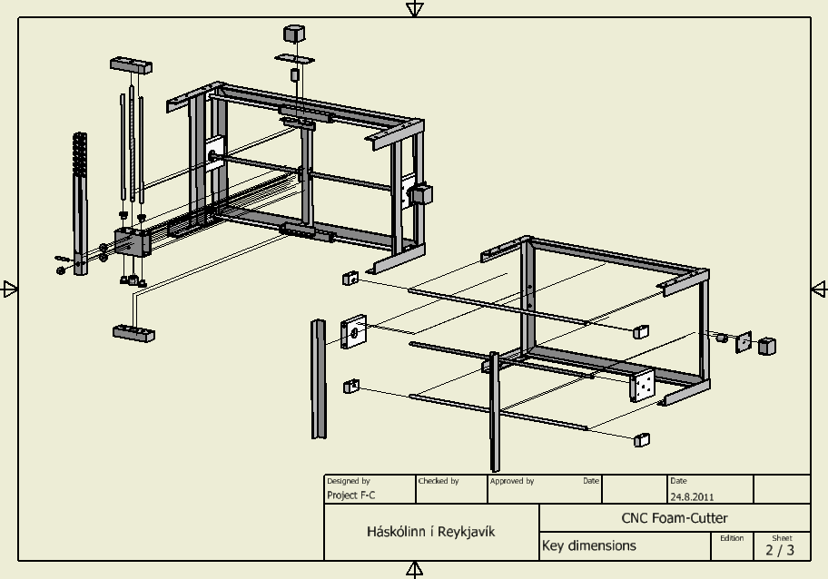

Figure 32. Exploded view of X-slider and Y-slider

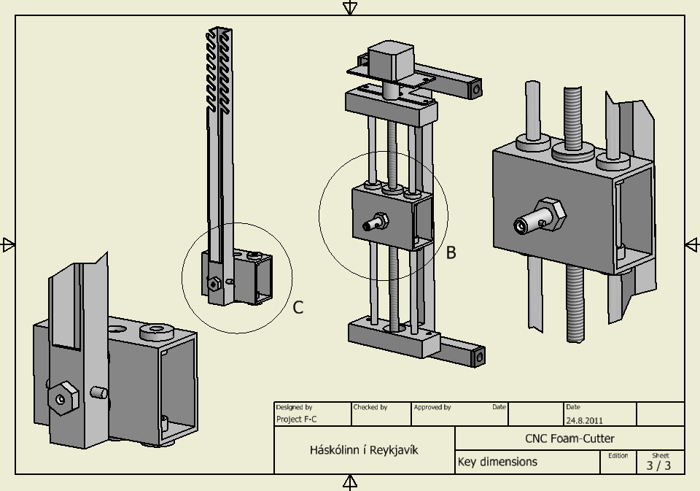

Figure 33. Closeup drawing of hot-wire tension and manipulation system

